MODULE II

1. Process
A program in execution is called a process. The execution of a process must progress in a sequential fashion, i.e. one instruction at a time is executed on behalf of a process. A program is a passive entity. It is just the contents of a file stored in a disk. The process is an active entity. It represents the current activity represented by the value of the program counter, the contents of processor’s registers, the contents of process stack and a data section containing global variables.
2. Process State
As a process executes it changes state. The state of a process is defined by the current activity of that process. Following are the different states a process can be in
- New: The process is being created.
- Running: The instructions are being executed.
- Waiting: Also called blocked state. The process is waiting for some event to occur such as an I/O completion.
- Ready: The process is waiting to be assigned to a processor.
- Terminated: The process has finished execution.
In a single processor system only one process can be in the running state at a time, but many processes can be in the ready and waiting states. The figure below shows the different states of a process.

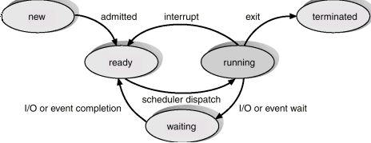

3. Process Control Block
A process is represented in the OS by a process control block (PCB). This is otherwise called task control block. The figure shows a PCB:

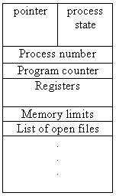

Process state: The state may be any one of the five discussed earlier.
Program counter: Holds the address of the next instruction to be executed for the process.
CPU registers: The registers may vary depending on the architecture. The registers should be saved if an interrupt occurs. This will help the process to continue correctly afterwards.
CPU-scheduling information: This includes process priority, pointers to scheduling queues etc.
Memory-management information: This includes the value of the base and limit registers and the page tables or segment tables.
Accounting information: This includes the amount of CPU and real time used, time limits, process numbers etc.
I/O status information: This includes the list of I/O devices allocated to the process, a list of open files etc.

4. Operations on Processes
Operating system must provide facility for process creation and termination.
1. Process creation
Reasons for process creation
- User logs on
- User starts a program
- OS creates process to provide a service (e.g., printer daemon to manage printer)
- Program starts another process
A process may create new process using create-process system call. The fork system call in UNIX is an example.
2. Process Termination
Reasons for process termination
- Normal completion
- Arithmetic error, or data misuse (e.g., wrong type)
- Invalid instruction execution
- Insufficient memory available, or memory bounds violation
- Resource protection error
- I/O failure

5. Process Scheduling
In a uniprocessor system that supports multiprogramming, only one process can be running at a time. The rest of the processes must wait until it is allotted the CPU. Allotting the process to the processor on some basis is called process scheduling.

Scheduling Queues
A process on entering the system is entered into the job queue. Theses processes will be residing in the secondary storage. The processes residing in the main memory that is ready and waiting for the processor are kept in the ready queue. The processes that are waiting for some I/O device are entered into the device queue. The figure below shows the queuing diagram representation of process scheduling.

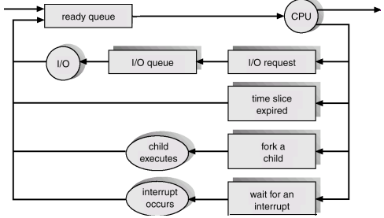

Schedulers
A process during its lifetime migrates through the various queues. The scheduler selects which process will be allocated memory or CPU or I/O device. All the processes in the system will remain in the mass storage. The long term scheduler or job scheduler selects the processes from this pool and loads them into memory. The jobs in the memory will be maintained in the ready queue. The short-term scheduler or CPU scheduler selects from among the processes in the ready queue and allocates the CPU to one of them. Most of the processes can be classified as I/O-bound process or CPU bound process.

An I/O bound process spends most of its time doing I/O and CPU bound process spend most of its time doing computation. The long-term scheduler must select a good mix of I/O bound and CPU bound processes. If all the processes are I/O bound the ready will always be empty and if all the processes are CPU bound the device queue will be empty most of the time and the I/O devices will go unused. In order to reduce the degree of multiprogramming some systems support swapping. Swapping is the process of removing some processes from the memory. Thus removed processes will be reintroduced into the memory at a later time and it will continue execution from where it left off.

Some systems support an intermediate level of scheduling. This scheduler which performs swapping out and swapping in of processes is called medium term scheduler. Figure below shows the different queues and the different schedulers.
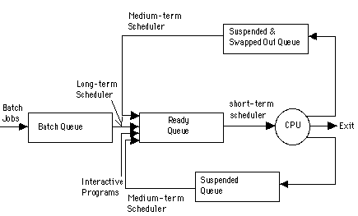

Context Switch
Switching the CPU from one process to another is called context switch. This involves saving the state of the old process and loading the saved state of the new process. The state of a process includes the value of the CPU registers, the process state and memory management information. This information is saved in the PCB of the process. The processor does no useful work during this process, so the time for context switch is an overhead.

6. CPU Scheduler
When the CPU becomes free the OS selects one from among the many processes in the memory that are ready to execute and allots the process to that processor. The CPU scheduler, otherwise called short-term scheduler, does this selection. The processes that are ready to execute is maintained as a ready queue. The records in the queue will be PCBs of the processes.

Preemptive Scheduling and Non preemptive Scheduling
In non-preemptive scheduling, once the CPU is allocated to a process, it is released only when the process terminates or when the process switches from the running state to waiting state (i.e. when the process requests for some I/O operation). Used in Macintosh and Windows 3.1.
In preemptive scheduling, the scheduling takes place when a process switches from running state to ready state or from waiting state to ready state. This scheduling is costly and requires special hardware to implement it.
Dispatcher
Dispatcher is the module that gives the control of the CPU to the process selected by the short-term scheduler. This involves
- Saving the context
- Switching to user mode
- Jumping to the proper location in the program to restart it.
The time taken by the dispatcher to stop one process and start another is called dispatch latency.

7. Scheduling Criteria
The different criteria used to compare the performance of the scheduling algorithms are the following:
CPU Utilization: It is the percentage of time the CPU is kept busy.
Throughput: It is the number of processes completed per unit time.
Turnaround time: It is time from the submission of a job to the completion of the job. It is the sum of waiting time and time for which the process uses the CPU.
Waiting time: It is the amount of time the process spends in the ready queue waiting for the processor.
Response time: It is time from the submission of a job to the time the first response is obtained.

8. Scheduling Algorithms
First Come First Serve (FCFS)
- The process that request first for the processor is allotted the processor first.
- The ready queue is maintained as a FIFO queue.
- When the processor becomes free it is allotted to the process at the head of the queue and when a new process arrives it is entered at the tail of the queue.
- It is the simplest algorithm and easy to implement.
Process Burst Time
P1 6
P2 8
P3 7
P1 | P2 | P3 | P4
P4 3
0 6 14 21 24
Average waiting time = (0+6+14+21)/4 = 10.25ms.
If there is one CPU bound process and many I/O bound processes, while is CPU bound process executes all the I/O bound process will finish their job with the I/O devices and will wait for the CPU in the ready queue. During this time the I/O devices will be idle. When the CPU bound process finish its CPU burst it goes to do I/O, meantime all the I/O bound processes will finish their CPU burst since they have got very short CPU bursts, and will wait in the device queue. All the processes waiting for one big process to get off the CPU is called convoy effect.

Shortest Job First Scheduling (SJF)
- Here among the processes in the ready queue, the one with the least CPU burst time will be allotted the processor first.
- If two processes have their burst time equal, then FCFS scheduling is used.
- The average waiting time is small when compared to FCFS scheduling.
- SJF is optimal algorithm.
- It is difficult to implement because knowing the length of the next CPU burst is difficult.
Process Burst Time
P1 6
P2 8
P3 7
P4 3
P4 | P1 | P3 | P2
0 3 9 16 24
Average waiting time = (3+16+9+0)/4 = 7ms.
SJF can be non preemptive or preemptive. The preemptive version of SJF is called Shortest Remaining Time First scheduling. Here when a new job arrives in the ready queue, its CPU burst is compared with the remaining CPU burst of the currently running process. If the newly arrived process has got the smaller burst then the currently running process will be preempted and the new process will be allotted to the processor. The preempted process will enter the ready queue and wait for its turn to get the processor.
Process Arrival time Burst Time
P1 0 6
P2 1 8
P3 2 7
P4 3 3
P1 | P4 | P1 | P3 | P2
0 3 6 9 16 24
Average waiting time = (3+15+7+0)/4 = 6.25ms.

Priority Scheduling
Each process is assigned a priority number (integer). The CPU is allocated to the process with the highest priority (smallest integer may be considered as highest priority). Priority scheduling can be preemptive or non preemptive. In preemptive priority scheduling while a process is executing, if a new process with high priority than the currently running process arrives, the process is preempted and the processor is allocated to the new process. SJF is a priority scheduling where priority is the predicted next CPU burst time.
The problem with priority scheduling is that a low priority processes may have to wait indefinitely to get the processor to execute. This is called starvation. The solution is to increase the priority of the process as time progresses. This is called aging.

Round Robin Scheduling
Each process gets a small amount of CPU time known as time quantum. When the time elapses process is preempted and the processor is allocated to the next process at the head of the ready queue. When the time quantum is very high this scheduling behaves as FCFS and when the time quantum is very small overhead will be high. It should be large with respect to context switch.
Consider the following table (let the time quantum be 5ms)
Process Burst Time
P1 6
P2 8
P3 7
P4 3

P1 | P2 | P3 | P4 | P1 | P2 | P3
0 5 10 15 18 19 22 24
Average waiting time = (13+14+17+15)/4 = 14.75ms.
This scheduling exhibits higher waiting time and turnaround time than SJF but the response time is better.

Multilevel Queue Scheduling
In this type of scheduling, Ready queue is partitioned into separate queues, for example, foreground (interactive) and background (batch). Processes are permanently assigned to one queue, generally based on some property of the process such as memory size, process priority or process type.

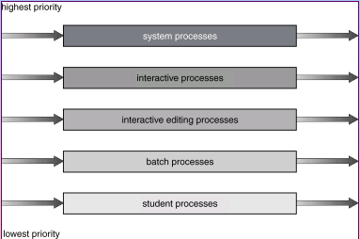

The above figure shows a multilevel queue scheduling with five queues. Each queue has its own scheduling algorithm. Scheduling must be done between the queues. Any scheduling algorithm can be used for this purpose. If fixed priority scheduling is used for this purpose (i.e., serve all from foreground then from background), there is possibility of starvation. If RR is used each queue gets a certain amount of CPU time which it can schedule amongst its processes; i.e., 80% to foreground in RR and 20% to background in FCFS.

Multilevel Feedback Queue Scheduling
In multilevel queue scheduling once a process enters a queue, it remains there. But in multilevel feedback queue scheduling a process can move between the various queues. Thus aging can be implemented.
Multilevel-feedback-queue scheduler defined by the following parameters:
- Number of queues
- Scheduling algorithms for each queue
- Method used to determine when to upgrade a process
- Method used to determine when to demote a process
- Method used to determine which queue a process will enter when that process needs service

For example let us consider three queues:
Q0 – time quantum 8 milliseconds
Q1 – time quantum 16 milliseconds
Q2 – FCFS
Scheduling
A new job enters queue Q0 is served using FCFS. When it gains CPU, job receives 8 milliseconds. If it does not finish in 8 milliseconds, job is moved to queue Q1. At Q1 job is again served FCFS and receives 16 additional milliseconds. If it still does not complete, it is preempted and moved to queue Q2.

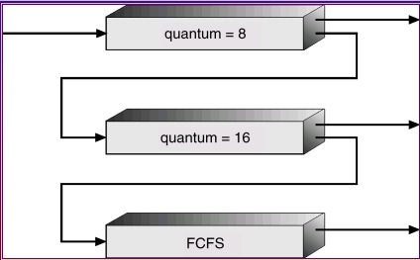

9. Process Management in UNIX
Process Environment - A process environment is inherited from its parent and is composed of two null-terminated vectors: the argument vector and the environment vector. The argument vector simply lists the command-line arguments used to invoke the running program, and conventionally starts with the name of the program itself. The environment vector is a list of name=value pairs that associates named environment variables with arbitrary textual values. The environment is not held in kernel memory but is stored in the process own user-mode address space as the first datum at the top of the process stack. The arguments and the environment vectors are not altered when a new process is created: The new child process will inherit the environment that its parent possesses.
Process Context: The process identity and environment properties are usually set up when a process is created, and not changed until that process exits. A process may choose to change some aspects of its identity if it needs to do so, or it may alter its environment. Process context, on the other hand is the state of the running program at any one time; it changes constantly.
Scheduling context: The most important part of the process context is its scheduling context i.e. the information that the scheduler needs to suspend and restart the process. This information includes saved copies of all the process registers. The scheduling context also includes information about scheduling priority and about the outstanding signals waiting to be delivered to the process. A key part of the scheduling context is the process kernel stack that is a separate area of kernel memory reserved for use exclusively by kernel mode. Both system calls and interrupts that occur while the process is executing will use this stack.

Accounting: The kernel maintains information about the resources currently being consumed by each process, and the total resources consumed by the process in its entire lifetime so far.

File table: The file table is an array of pointers to kernel file structures. When making file-I/O system calls, processes refer to files by their index into this table

File-system context: Whereas the file table lists the existing open files, the file-system context applies to requests to open new files. The current root and default directories to be used for new file searches are stored there.

Signal-handler table: UNIX systems can deliver asynchronous signals to a process in response to various external events. The signal-handler table defines the routine in the process address space to be called when specific signal arrives.

Virtual memory context: The virtual memory context describes the full contents of a process private address space

